  - ROM (Read Only Memory) is a type of storage medium that permanantly stores the data on the computer (or other electronic devices)
  - RAM (Random Access Memory) stores the data temporarily, whereas ROM store it permanantly
  - Dynamic RAM is the most common type of memory in use today. Inside a dynamic RAM chip, each memory cell holds one bit of information and is made up of two parts: a transistor and a capacitor. Inside a static RAM, a form of flip-flop holds each bit of memory. A flip-flop for a memory cell takes 4 or 6 transistors along with some wiring but never has to be refreshed.
  - Flash memory is used in USB thumb drives. We should not rely too much on critical data storage because it does not integrate well with backups. Neumann (sometimes called Princeton) architecture is associated with using a single path to access the main memory that holds both instructions and data. Harvard architecture is associated with having separate memories
- 8589934592 ( or 2³³) bits are needed to address all bytes in the system’s RAM.
- Classically, von, and access paths for instructions and data. Of course, there are many in-between ways to organize memory. For example, most modern processors have separate caches for instructions and data, but both caches are essentially filtering requests to a single main memory that holds both instructions and data.4. cache memory, also called CPU memory, is high-speed static random access memory (SRAM) that a computer microprocessor can access more quickly than it can access regular random access memory (RAM).
- Cache memory, often known as CPU memory, is a type of high-speed static random access memory (SRAM) that a computer microprocessor may access faster than conventional random access memory (RAM)
- When a Process is being performed by the CPU and a user requests another Process, the Running Process is disrupted. This is also referred to as the Interrupt. Types of Interrupts (Internal interrupt, Software interrupt and External interrupt)
  - To determine which device sent out the request, an interrupt controller will poll all devices on a computer. A polled interrupt is an inefficient technique of data transfer that spends a significant amount of time confirming the readiness of a computer's hardware. A vector interrupt is a more efficient alternative that can transmit a signal that includes the device's identifier. In current computers, all input/output is handled by interrupt-driven I/Os, which interrupt the operation when they are ready to transfer data. While waiting for an interrupt, the CPU will execute other activities.
- A stack is an abstract data type that serves as a collection of elements. The order in which elements come off a stack gives rise to its alternative name, LIFO (last in, first out). Additionally, a peek operation may give access to the top without modifying the stack. The name "stack" for this type of structure comes from the analogy of a set of physical items stacked on top of each other, which makes it easy to take an item off the top of the stack while getting to an item deeper in the stack may require taking off multiple other items first
  - An interrupt handler is a kind of hardware-triggered function call. The nature of function calls is that they can nest. Therefore, a stack is the only workable data structure where you can store the return addresses in the correct order.
  - Stacks are useful for these followings:
    - Peek: Allows the inspection of the topmost element on a stack without removing the element.
    - Swap: Also referred to as “exchange,” the positions of the two top elements of the stack are swapped, the first element becoming the second and the second becoming the top.
    - Duplicate: The topmost element is popped from the stack and then pushed back onto the stack twice, creating a duplicate of the original element.
    - Rotate: Also referred to as “roll,” specifies the number of elements in a stack that are rotated in their order. For example, rotating the top four elements of a stack would move the topmost element into the fourth position while the next three elements move up one position.

Stack
9. Shift register
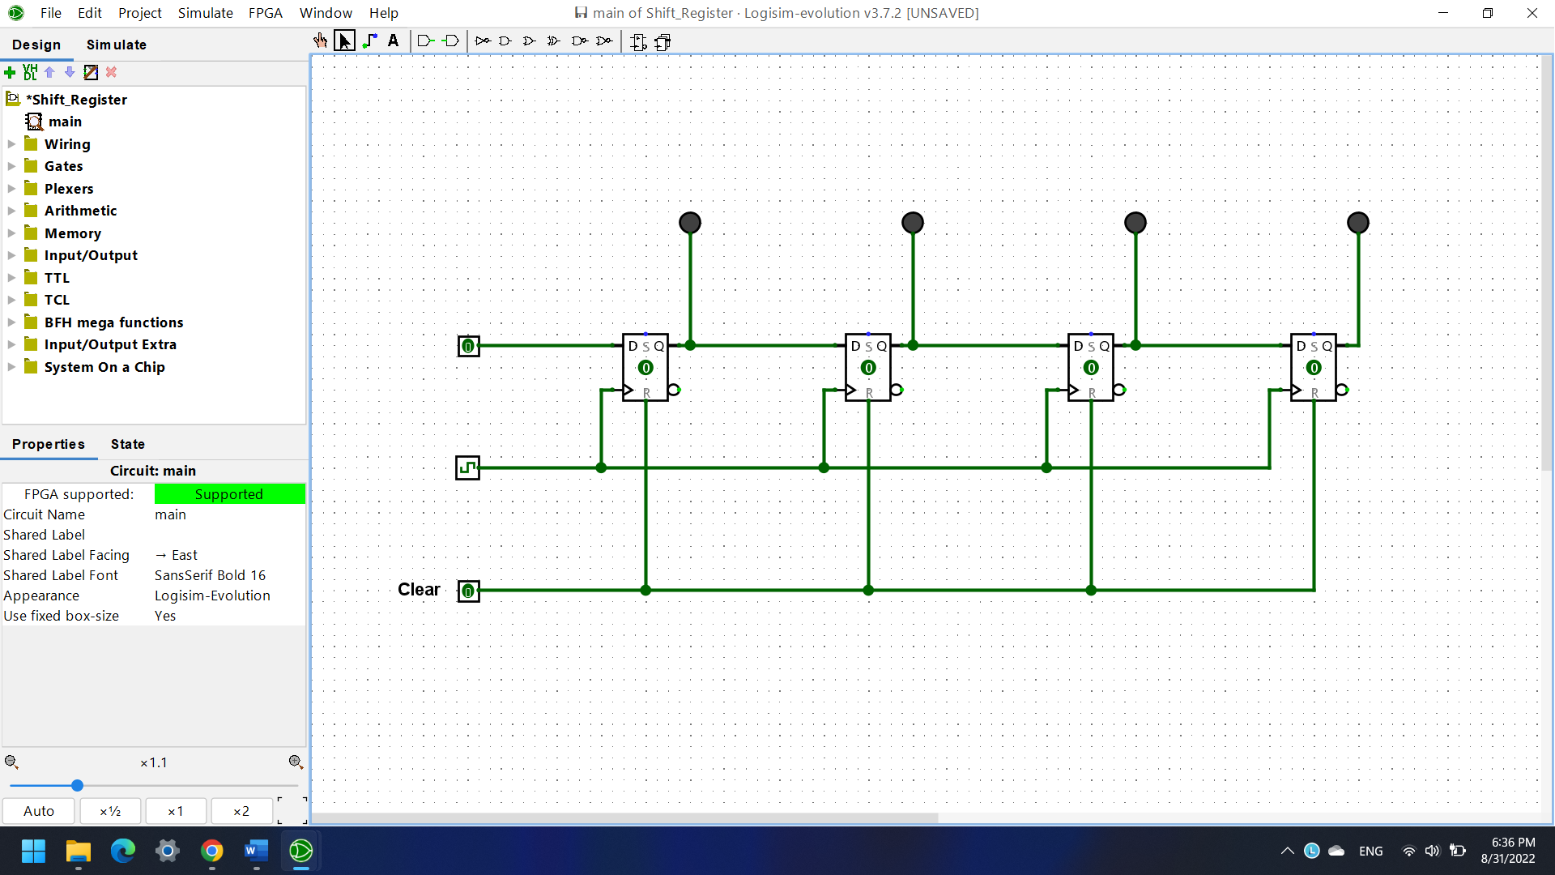
10. 2-bit Encoder
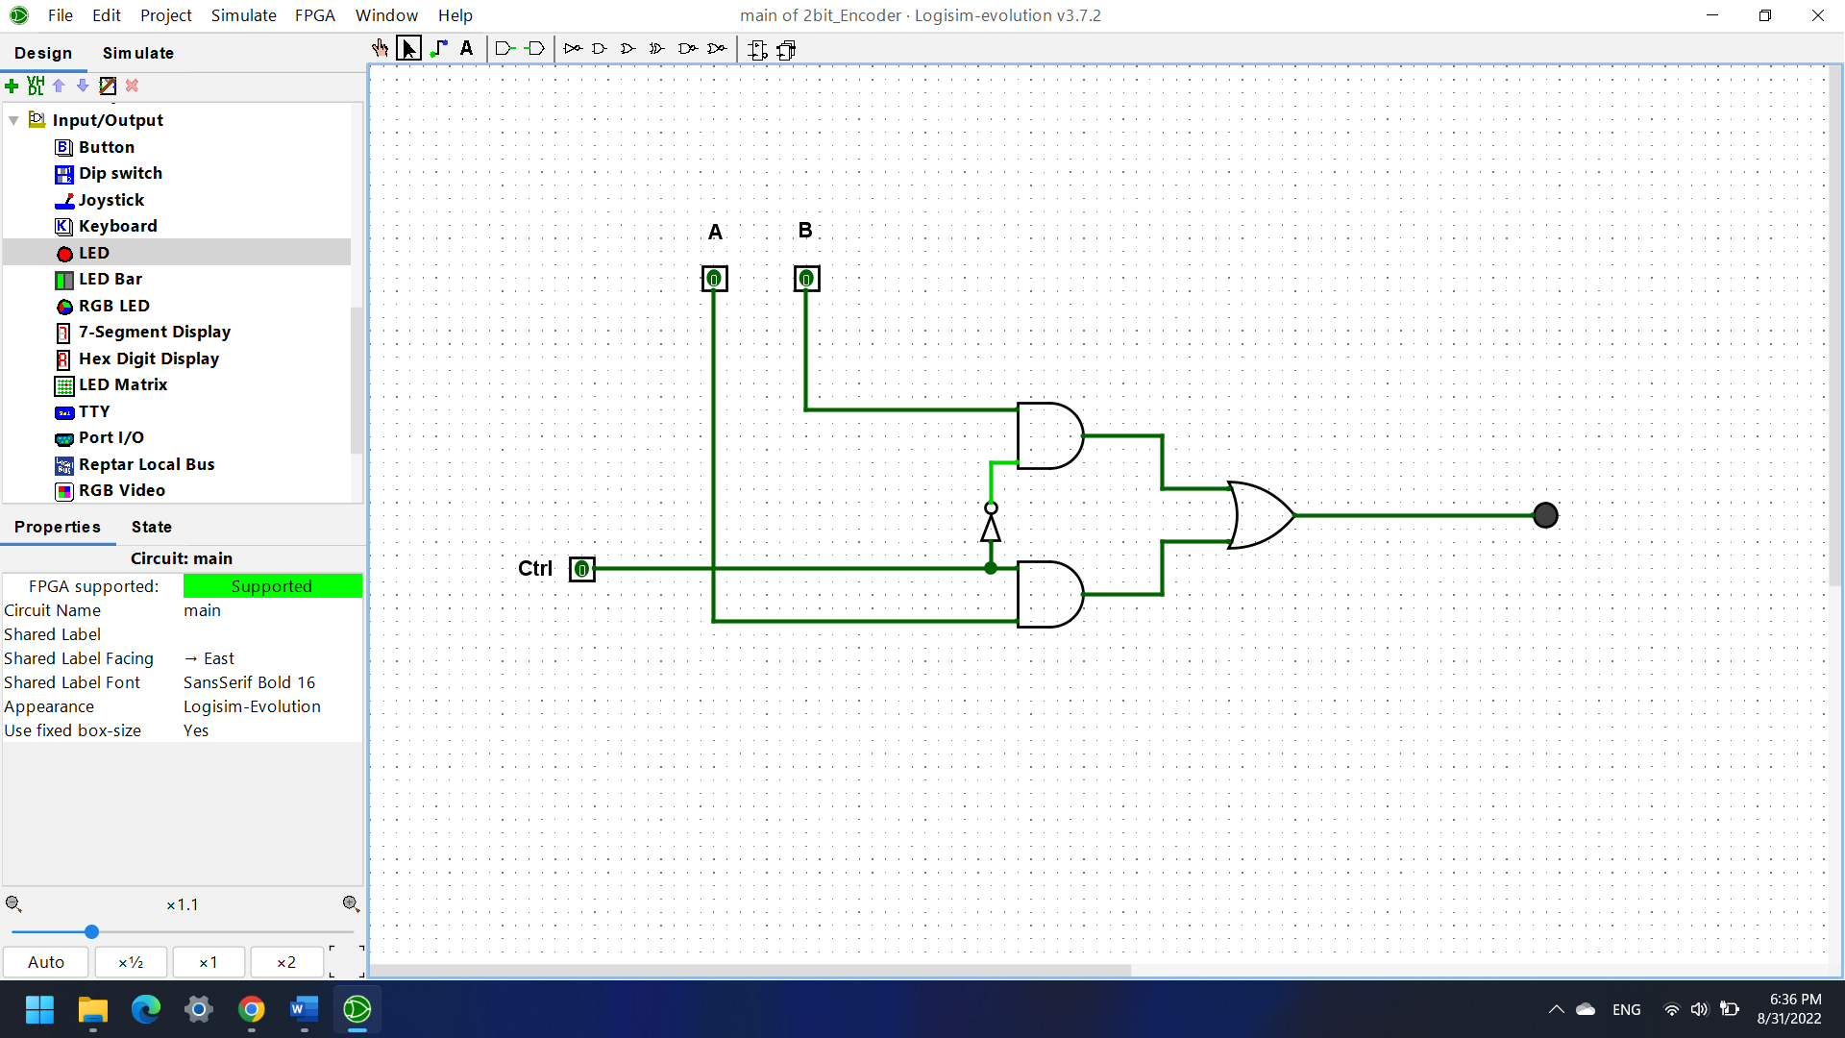
12. Stack
